Jennifer Stegina

**> Unit 1 Guided Practice 2**

(2-2) Question 1:

Write a query using the *employee_id*, *last_name*, and *credit_limit* columns from the *l_employees* table of the Lunches database. Show only the employees who have a credit limit greater than $20.00. Sort the rows of the result by the last name of the employee.

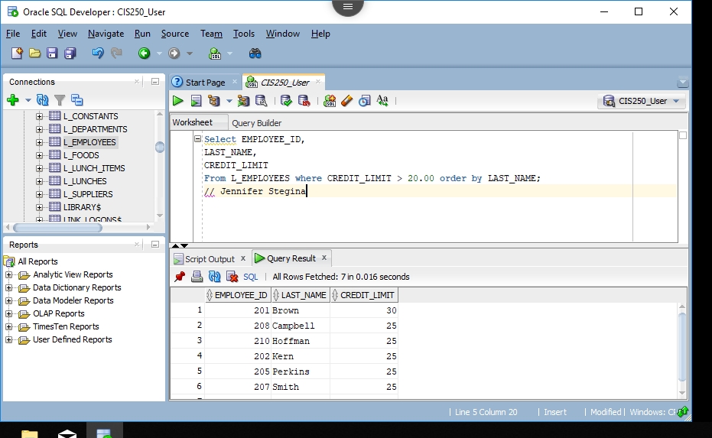

(2-4) Question 2:

Write a query using *employee_id*, *phone_number*, and *last_name* columns from the *l_employees* table.

Display them in that order. Change the name of the *employee_id* column to *employee_number* and the name of the *phone_number* column to extension. Also, create two new columns: *evaluation* and *rating*. Give every employee an evaluation of “excellent worker” and a rating of 10.

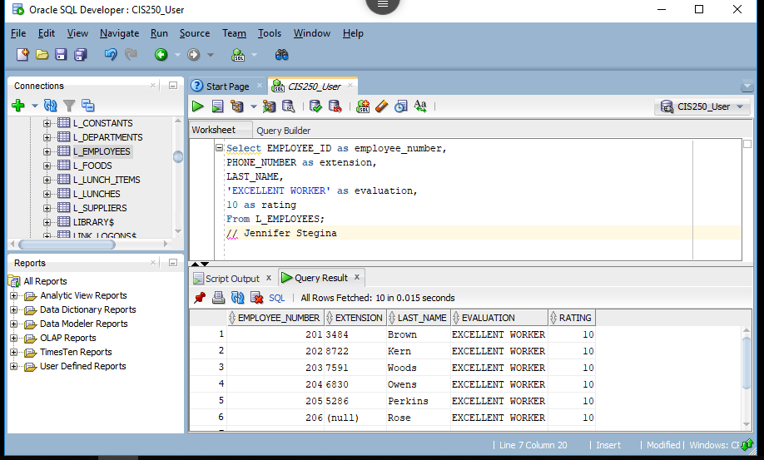

(2-5) Question 3:

Write a query to get the entire *l_employees* table, all the columns and all the rows. Display all the columns in the same order as they are defined in the table.

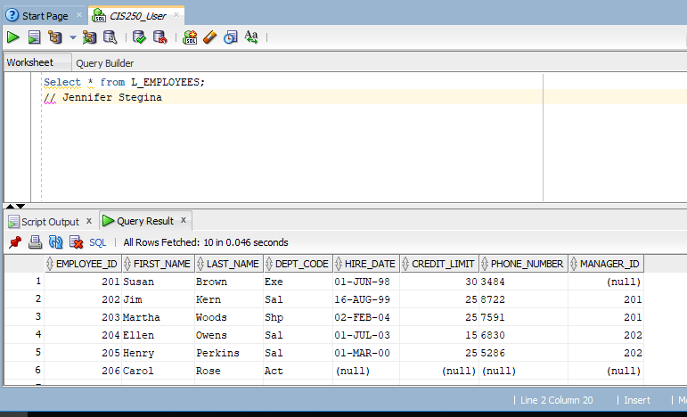

(2-6) Question 4:

Write a query to get a list of all the different values in the *manager_id* column of the *l_employees* table.

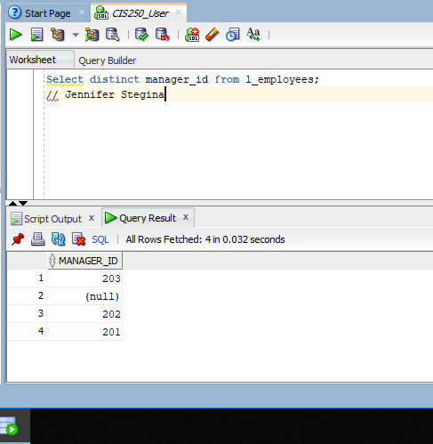

(2-7) Question 5:

Write a query to get a list of all the different values in the *manager_id* and *credit_limit* column of the *l_employees*  table.

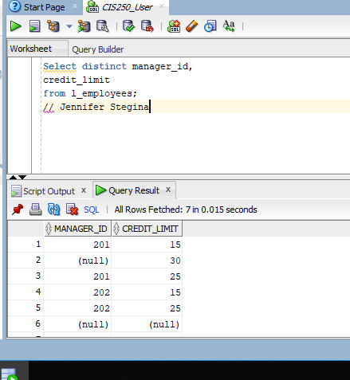

(2-9) Question 6:

Write a query for all employees who report to employee 203, Martha Woods, list the following:

*employee_id*

*first_name*

*last_name*

*manager_id*

*hire_date*

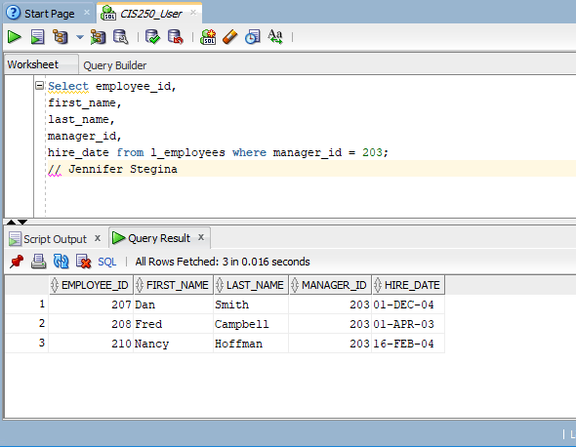

(2-9) Question 7:

Write a query for all the employees whose first name is Henry, list the same columns as question 6.

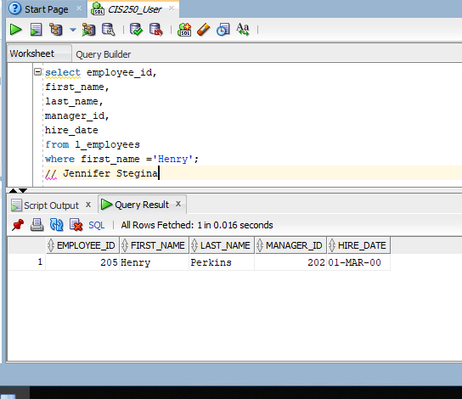

(2-9) Question 8:

Write a query for all the employees who were hired on July 1, 2008, list the same columns question 6.

**No employee was hired in 2008 according to our DB. The book showed her as the answer, so I adjusted my query to ’03 to get her.**

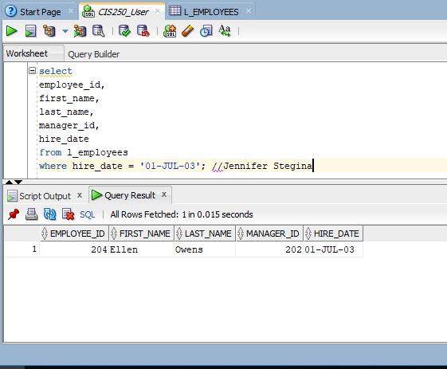

(2-9) Question 9:

Write a query for all the employees whose first name is Paula, list the same columns as before. Change the name of the *first_name* column to *given_name*.

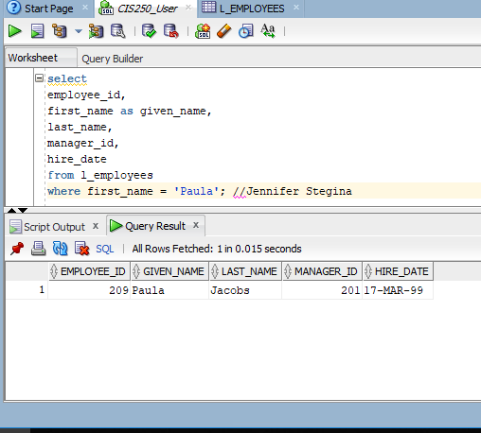

(2-10) Question 10:

Write a query listing all employees who have a credit limit less than $17.50. Show the columns:

*employee_id, first-name, last_name, credit_limt*

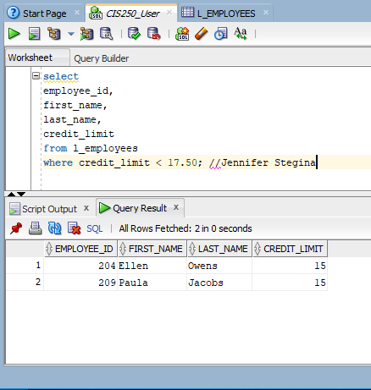

(2-10) Question 11:

Write a query to show another way to use the greater than or equal to (>=) sign and negating the condition with a Boolean not.

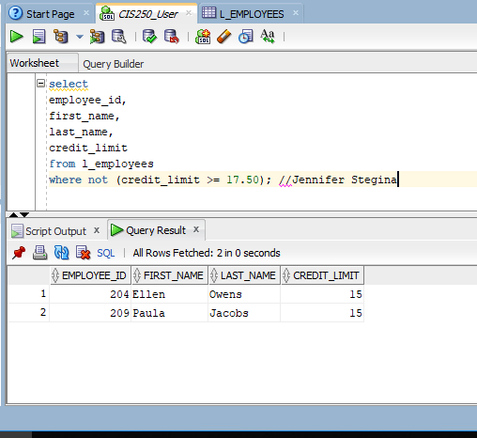

After you are finished, please submit the Microsoft Word file that contains screenshots of the SQL script and the resulting tables. Your document should be named **U1_GuidedPractice2_Lastname.docx**.